Create a Pie Chart / Pie Graph in Excel 2003 and 2007
- The first step in creating a pie chart is to enter the data into the worksheet.
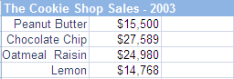

Using the keyboard
- Click on the top left of the pie charts's data.
- Hold down the SHIFT key on the keyboard.
- Use the arrow keys on the keyboard to select the data to be included in the pie chart
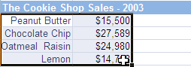

- Click on Insert > Chart... in the menu (2003)
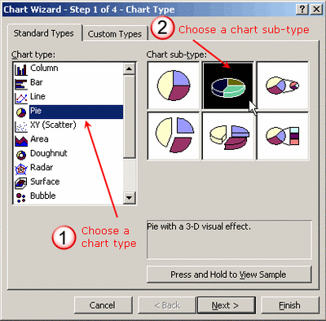
or the Insert tab (2007).
- Click on a chart category to open the drop down list of available chart types.
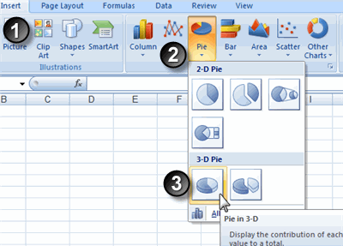
- Click on a chart type to select it.

3. The finished chart.
